OYEMEKUN GRAMMAR SCHOOL AQUINAS AKURE, ONDO STATE
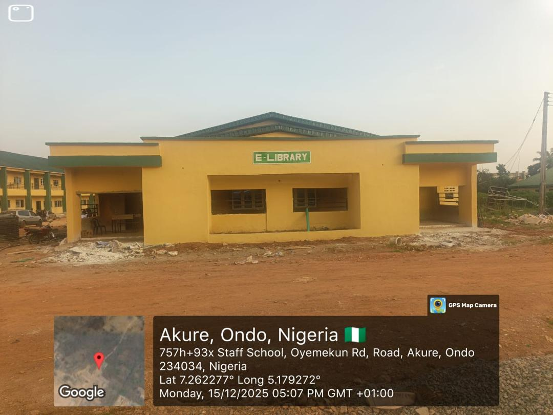
Fig.1.Renovation of E-Library
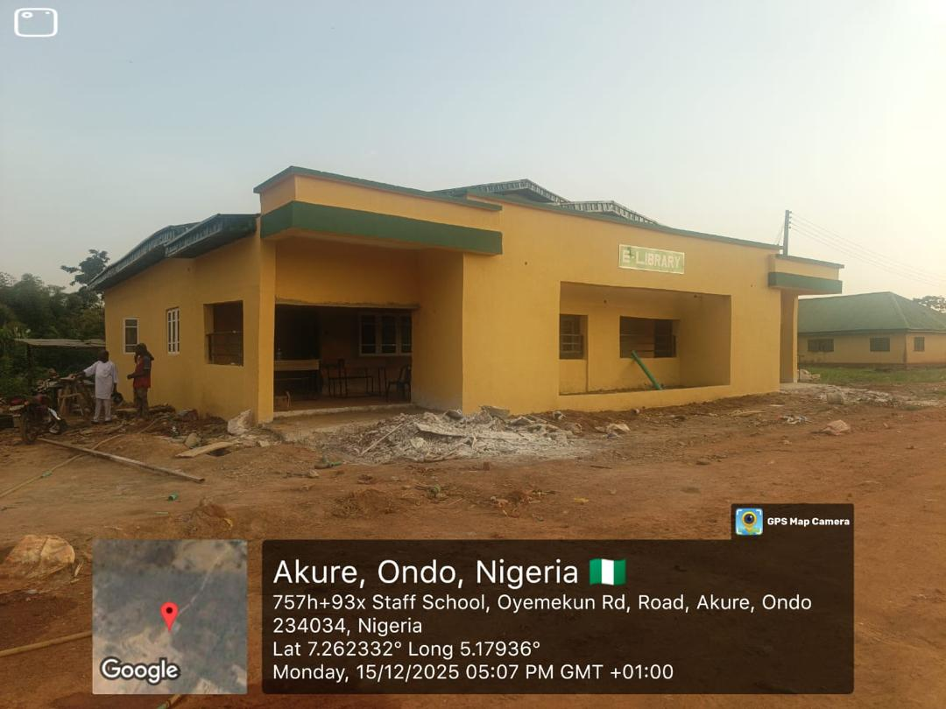
Fig.2.Renovation of E-Library
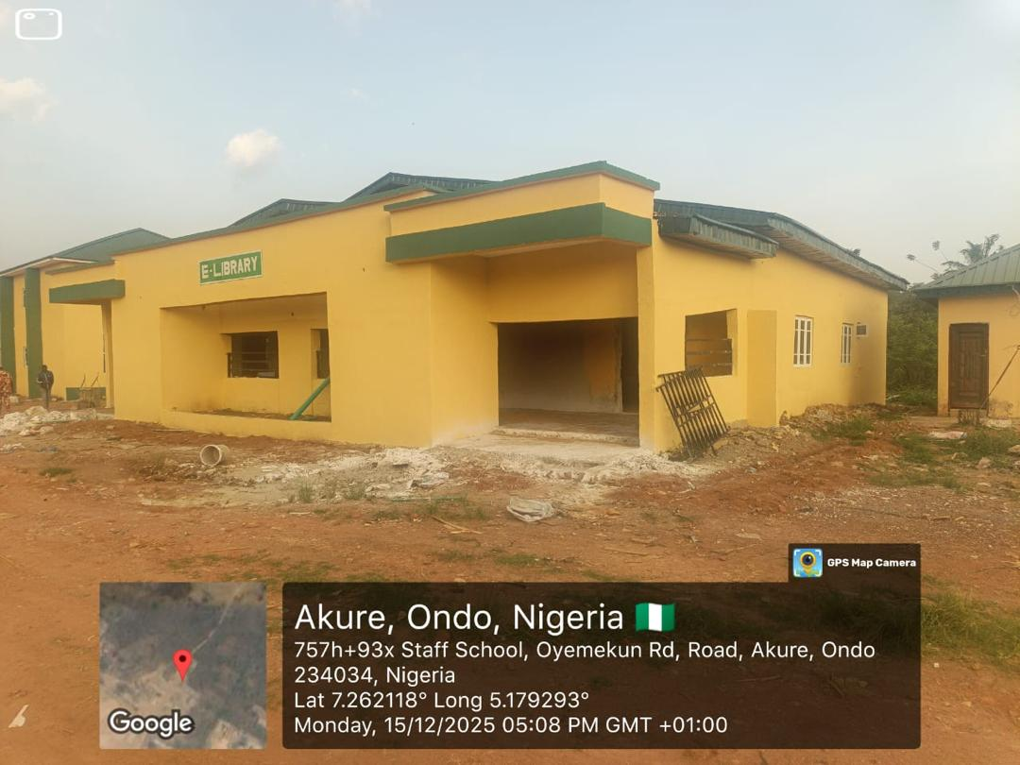
Fig.3.Renovation of E-Library


Fig.4.Construction of 12 NR Classroom Block

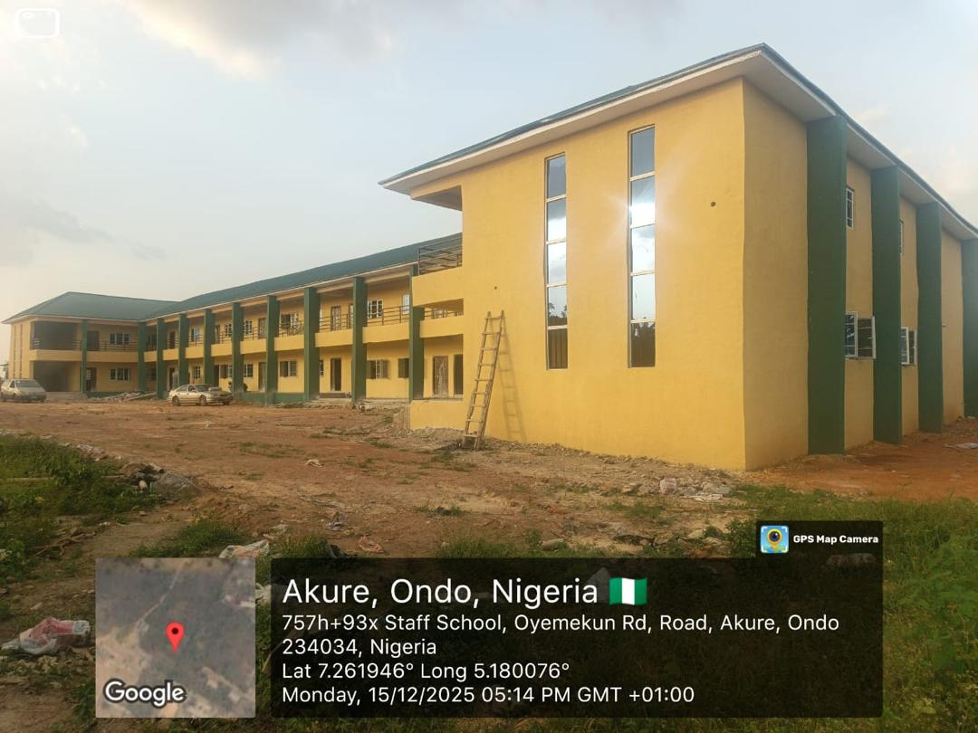
Fig. 5. Construction of 12 NR Classroom Block

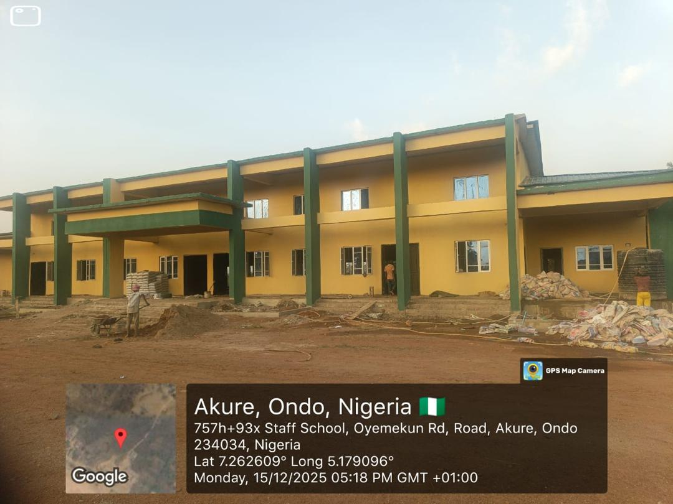
Fig.6. Construction of 500 Capacity Multipurpose Hal
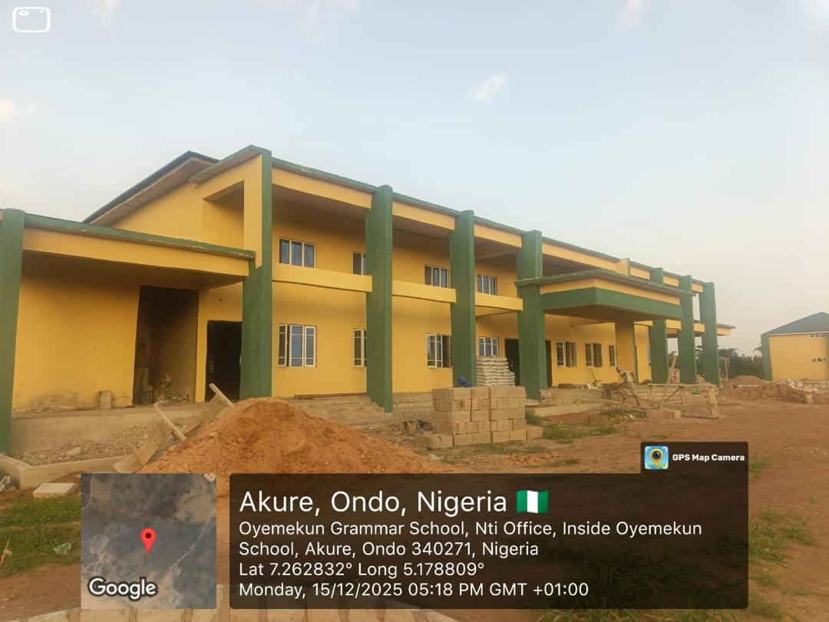
Fig.7. Construction of 500 Capacity Multipurpose Hall


Fig.8. Construction of 500 Capacity Multipurpose Hall
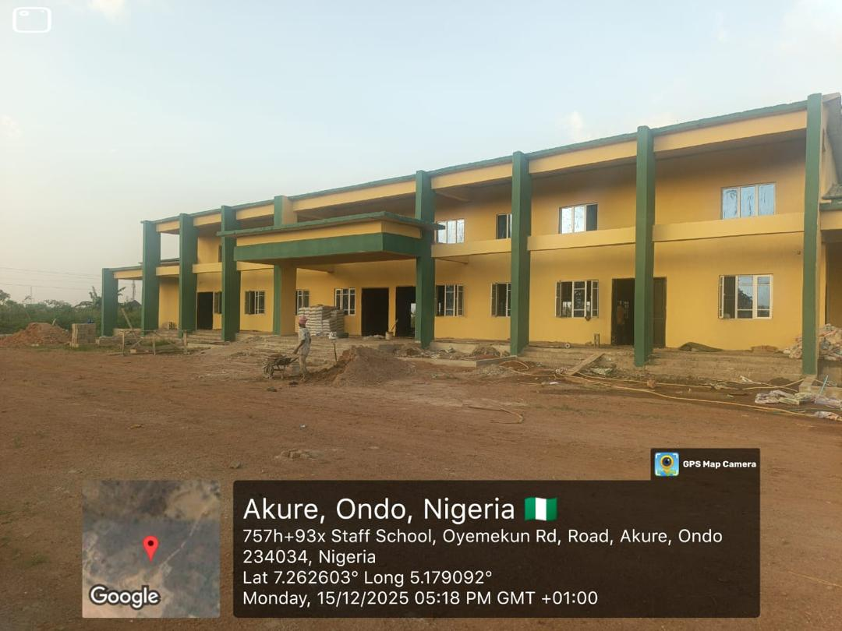
Fig.9.Construction of 500 Capacity Multipurpose Hall

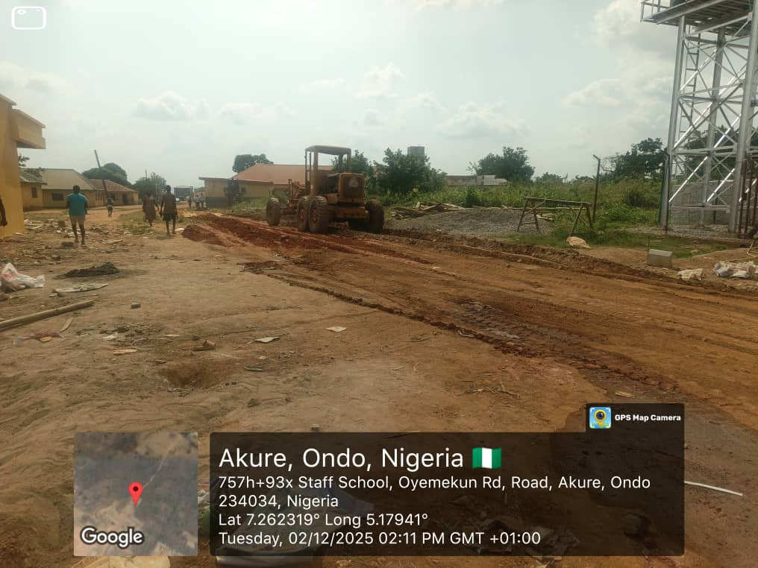
Fig.10.Road grading and leveling


Fig.11.Road grading and leveling

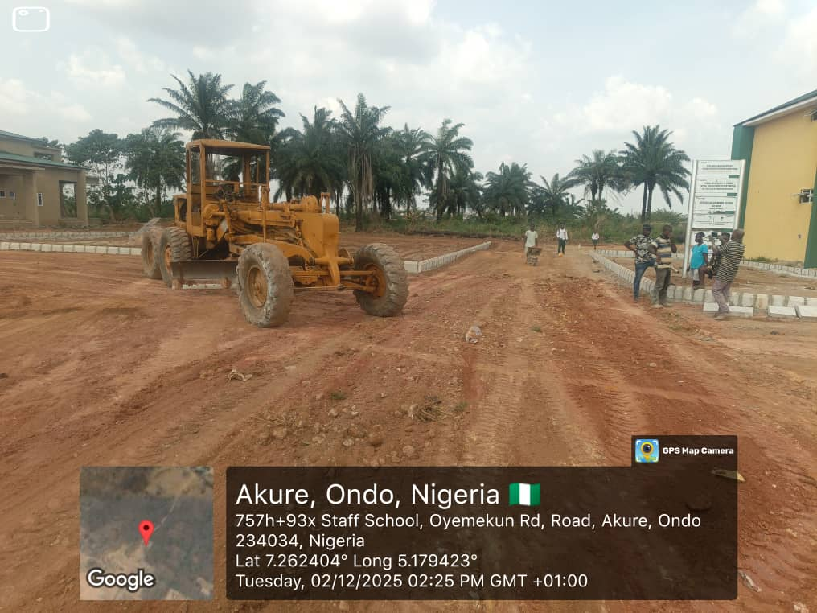
Fig.12.Road grading and leveling
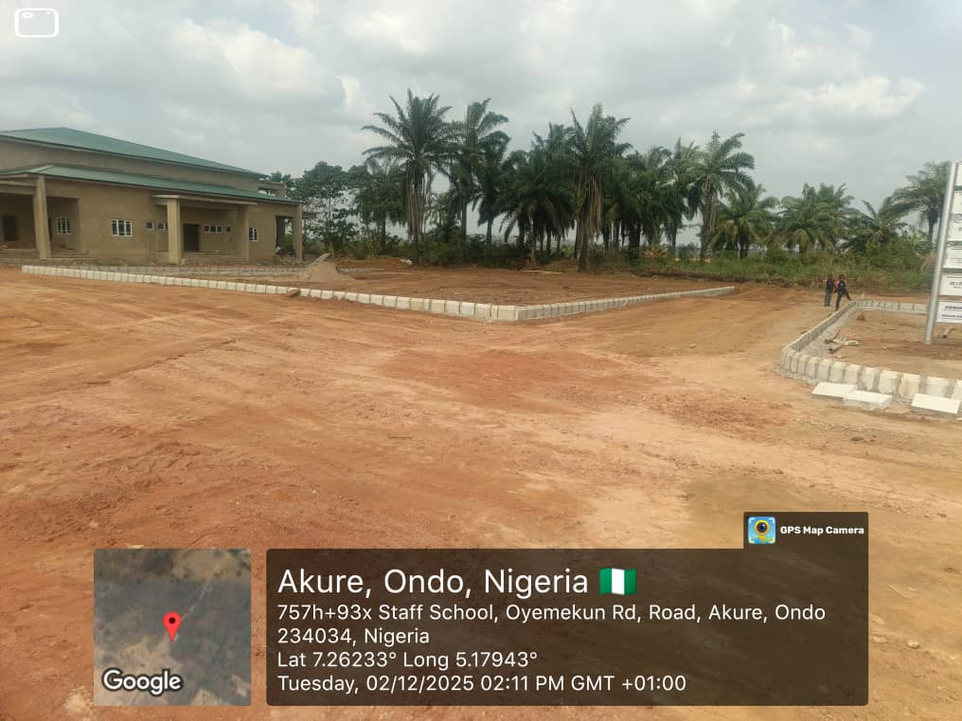
Fig.13.Road grading and leveling

